**EXP 4: DESIGN A SMART PHONE CONTROLLED LED SYSTEM**

**CIRCUIT DIAGRAM:** 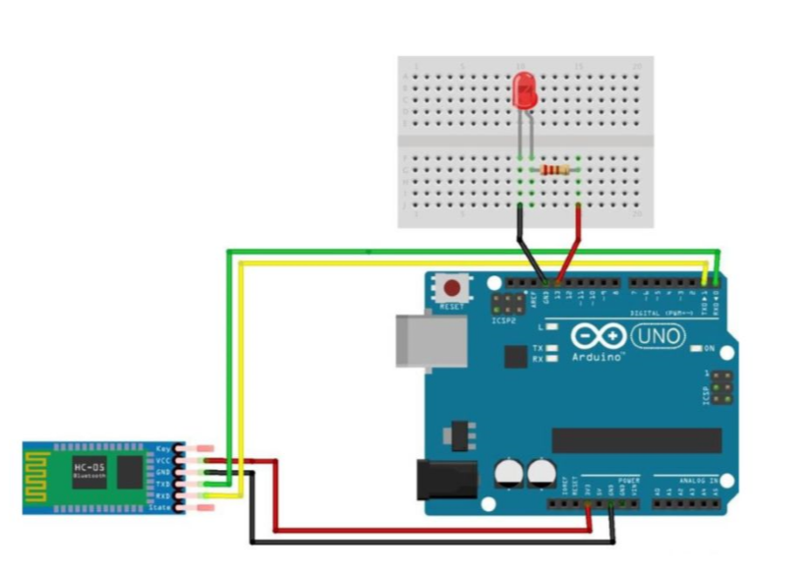

**THEORY :**

**CONCEPT USED :** In this experiment first we used the basics of electronics in connecting the breadboard connections and the concept of the connections of the Arduino with the Bluetooth receiver.

The concept of coding of the Arduino for the Bluetooth receiver is also used.

**LEARNING AND OBSERVATIONS**:

Through this experiment we can learn the use and the applications of Arduino and the Bluetooth receiver .

We can also learn the coding for the Arduino for the Bluetooth from this experiment .

We can operate the led by a smart phone.

**PROBLEMS AND TROUBLESHOOTING :**

We mainly face problems in making the proper connections in the breadboard and the connections of Bluetooth with the Arduino .

And the code of the Arduino for connecting Bluetooth should be given properly.

**PRECAUTIONS :**

One should be concentrated while making the connections of breadboard and Arduino with the Bluetooth receiver .

And also the code of Arduino should be checked twice.

The use of extra connecting wires should be decreased.

**LEARNING OUTCOMES :**

We can Learn the a real life application from this experiment like how to operate an led with a smart phone.

We can also learn the coding for the Bluetooth and the Arduino .